

**MINISTERUL EDUCAȚIEI, CULTURII ȘI CERCETĂRII AL REPUBLICII MOLDOVA**

**Universitatea Tehnică a Moldovei**

**Facultatea Calculatoare, Informatică şi Microelectronică Departamentul Inginerie Software și Automatică**

**Gusev Roman FAF-222**

Report

*Laboratory work n.2*

***of Computer Graphics***

Checked by:

**Olga Grosu,** *university assistant*

DISA, FCIM, UTM

**Chișinău – 2023**

**1. Purpose of the Laboratory Work**

According to the solved problem, I can formulate the purpose of this laboratory work was: to get used with arc shapes, to formulate better the code and to begin use of such things as: variables, conditionals and loops.

**2. Condition of the Laboratory Work**

Task 1) I had Point number 4 to do

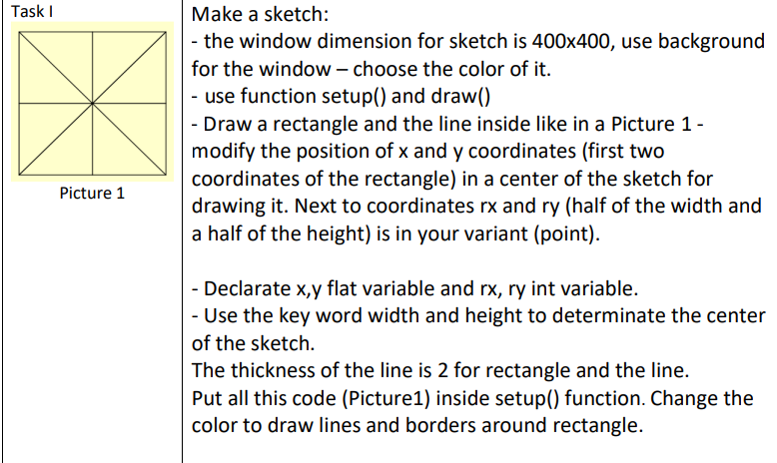

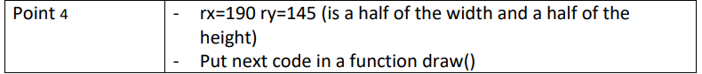

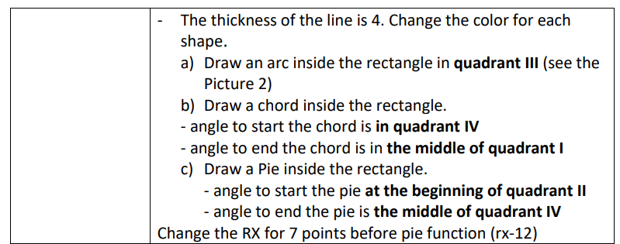

Task 2)

Make sketch with 2d primitives function and move it.

- you can use random function or increase the coordonate of your sketch combination)

- use VARIABLES, CONDITIONALS, LOOPS function and create your own function and call it in Draw function

**3. The program code**

Task 1)

// Student: Gusev Roman

// Group: FAF-222

// Variant 4

// Variables

int rx;

int ry;

float x;

float y;

void setup() {

// Setting the size of the canvas

size(400, 400);

// Setting the color for background

background(200);

// Variables initialization

x = width / 2;

y = height / 2;

rx = 190;

ry = 145;

// Using rectMode with parameter CENTER, to use rect center x and y

rectMode(CENTER);

// Setting the width of the line to 2

strokeWeight(2);

// Drawing rect in center of the canvas

fill(255, 204, 204);

rect(x, y, 2 * rx, 2 * ry);

// Drawing lines inside of rect

line(x - rx, y - ry, x + rx, y + ry);

line(x - rx, y + ry, x + rx, y - ry);

line(x - rx, y, x + rx, y);

line(x, y - ry, x, y + ry);

}

void draw() {

// Setting the width of the arcs to 4

strokeWeight(4);

// a) Drawing an arc in III Quadrant

noFill(); // setting empty design for arcs

stroke(100, 100, 255); // setting color of the arc

arc(x, y, rx * 2, ry * 2, HALF_PI, PI); // constructing the arc

//stroke(0); // setting color back to black

// b) Drawing a chord (angle to start the chord in Quadrant IV and angle to

// end the chord in the middle of Quadrant I)

stroke(255, 0 , 0); // setting color of the chord

arc(x, y, rx * 2, ry * 2, -QUARTER_PI, HALF_PI - 0.4, CHORD); // constructing the chord

//stroke(0); // setting color back to black

// c) Drawing a Pie (angle to start the pie at the beginning of quadrant II

// and angle to end the pie is the middle of quadrant IV)

stroke(255, 100, 100); // setting color of the pie

arc(x, y, rx * 2 - 50, ry * 2 - 50, QUARTER_PI, PI + HALF_PI, PIE); // constructing the pie

stroke(0); // setting color back to black

}

Task 2)

// Trajectory of Moon and Sun

float horizontalTraj = 400;

float verticalTraj = 250;

// Position on unit circle of Sun and Moon (initial)

float sunAngle = 0;

float moonAngle = PI;

// Color of Day and Night

color dayColor = color(0, 155, 255);

color nightColor = color(0, 15, 15);

// Color of the grass

color dayGrass = color(0, 153, 0);

color nightGrass = color(7, 53, 30);

// Color of the tree

color dayTree = color(196, 92, 0);

color nightTree = color(67, 33, 0);

// Color of the rope

color ropeDay = color(131, 71, 19);

color ropeNight = color(71, 39, 11);

// Position on canvas of Sun and Moon

float sunX;

float sunY;

float moonX;

float moonY;

// Position of the rope

float ropeNum1InitX = 525;

float ropeNum1InitY = 265;

float ropeNum1EndX;

float ropeNum1EndY;

float ropeNum2X = ropeNum1InitX + 15;

float ropeNum2Y = ropeNum1InitY - 5;

float ropeNum2EndX;

float ropeNum2EndY;

// Swing variables

float ropeLength = 100;

float ropeAmplitude = 20;

float ropeFrequency = 0.01;

float ropeAngle = 0;

boolean swinging = true;

int direction = 1;

// Position of leaves

float leafNum1X = 465;

float leafNum1Y = 180;

float leafNum2X = 600;

float leafNum2Y = 230;

float leafNum3X = 345;

float leafNum3Y = 280;

// Leaves Shake Variables

float leafShakeX = 0;

float leafShakeY = 0;

float leafShakeRange = 1;

// Function that add Stars during Night

void drawStars(float aux) {

if (aux > 0.5) {

for (int i = 0; i < 15; i++) {

float starX = random(0, width);

float starY = random(0, 299);

float starSize = random(2, 4);

strokeWeight(starSize);

stroke(255);

point(starX, starY);

}

}

else if (aux >= 0.3 && aux <= 0.5) {

for (int i = 0; i < 4; i++) {

float starX = random(0, width);

float starY = random(0, 299);

float starSize = random(2, 4);

strokeWeight(starSize);

stroke(255);

point(starX, starY);

}

}

strokeWeight(1);

stroke(0);

}

// Function to draw a tree in the field

void drawTree(float aux, color grassColor) {

color treeColor = lerpColor(dayTree, nightTree, aux);

fill(treeColor);

noStroke();

// Tree body

quad(420, 400, 440, 320, 490, 320, 510, 400);

quad(440, 350, 440, 210, 490, 210, 490, 350);

// Tree branches

quad(490, 260, 565, 240, 580, 255, 490, 280);

quad(565, 240, 590, 210, 610, 210, 580, 255);

quad(440, 300, 380, 280, 365, 295, 440, 320);

quad(380, 280, 355, 260, 335, 260, 365, 295);

// Leaves

fill(grassColor);

ellipseMode(CENTER);

stroke(0);

leafNum1X += leafShakeX;

leafNum1Y += leafShakeY;

leafNum2X += leafShakeX;

leafNum2Y += leafShakeY;

leafNum3X += leafShakeX;

leafNum3Y += leafShakeY;

ellipse(leafNum1X, leafNum1Y, 140, 130);

ellipse(leafNum2X, leafNum2Y, 90, 80);

ellipse(leafNum3X, leafNum3Y, 90, 80);

// Function to draw the Swing

drawSwing(aux);

// Reset stroke color and strokeWeight

stroke(0);

strokeWeight(1);

// Change leaf position

leafShakeX = random(-leafShakeRange, leafShakeRange);

leafShakeY = random(-leafShakeRange, leafShakeRange);

}

// Function to draw the Swing on the branch

void drawSwing(float aux) {

strokeWeight(3);

color swingColor = lerpColor(ropeDay, ropeNight, aux);

stroke(swingColor);

if (swinging) {

// Calculate where Rope ends

ropeNum1EndX = ropeNum1InitX + ropeLength * sin(ropeAngle);

ropeNum1EndY = ropeNum1InitY + ropeLength * cos(ropeAngle) - 15;

ropeNum2EndX = ropeNum2X + ropeLength * sin(ropeAngle);

ropeNum2EndY = ropeNum2Y + ropeLength * cos(ropeAngle);

// Draw the rope

line(ropeNum1InitX, ropeNum1InitY, ropeNum1EndX, ropeNum1EndY);

line(ropeNum2X, ropeNum2Y, ropeNum2EndX, ropeNum2EndY);

// Draw the plank

fill(swingColor); // Use the same color as the rope

noStroke();

rect(ropeNum1EndX - 20, ropeNum1EndY, 50, 20);

// Update the rope angle for swinging motion

ropeAngle += ropeFrequency * direction;

// Reverse the swing direction when reaching 15 degrees

if (ropeAngle >= radians(15) || ropeAngle <= -radians(15)) {

direction *= -1;

}

}

}

void setup() {

// Setting up the sizes of canvas

size(800, 600);

}

void draw() {

// Sun and Moon position being calculated

sunX = width / 2 + horizontalTraj * cos(sunAngle);

sunY = height / 2 + verticalTraj * sin(sunAngle);

moonX = width / 2 + horizontalTraj * cos(moonAngle);

moonY = height / 2 + verticalTraj * sin(moonAngle);

// Changing the color of sky based on position of Sun and Moon

float aux = map(sunY, height / 2 - verticalTraj, height / 2 + verticalTraj, 0, 1);

color bgColor = lerpColor(dayColor, nightColor, aux);

background(bgColor);

// Sun

fill(255, 255, 0);

ellipse(sunX, sunY, 50, 50);

// Function drawStars()

drawStars(aux);

// Moon

fill(180);

ellipse(moonX, moonY, 50, 50);

// Changing the color of grass based on positions of Sun and Moon

color grassColor = lerpColor(dayGrass, nightGrass, aux);

// Horizon

fill(grassColor);

rect(0, 300, 800, 350);

// Updating the angles for motion on the trajectory (speed of Sun and Moon)

sunAngle += radians(1);

moonAngle += radians(1);

// Drawing a tree in the field

drawTree(aux, grassColor);

}

**4. Screen printing of program execution**

Task 1)

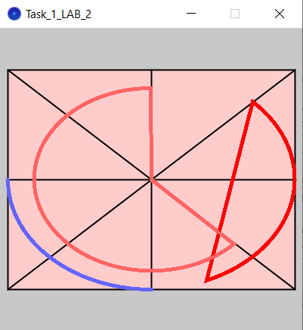

Task 2)



**5. Conclusion**

By the end of this Laboratory Work nr. 2, I accomplished given task exactly with the requirements. I did task 1 during the class, I accomplished it easily. I used several shapes and initialized variables. Also, I used several colors to distinct every element: pie, arc, chord etc. The most difficult part was to figure how the start and end angles of arcs works. Task 2 was much more difficult, it contains several new functions, especially loops, conditionals and variables initialized outside the methods. I used several shapes, such as rect, circles, ellipses. I also created several auxiliar functions that made draw() function much more shorter and easier to read. I did a scene of a plain with Day Night cycle and a tree that shakes by the wind and a swing that is disturbed by the same wind. I accomplished those tasks with the use of for loops, conditionals and variable change, that is executed every frame. The most difficult part of this task was to understand that draw function is executed in a while loop, but once I understood that, it became much easier to do.